Screen 1: Login Page

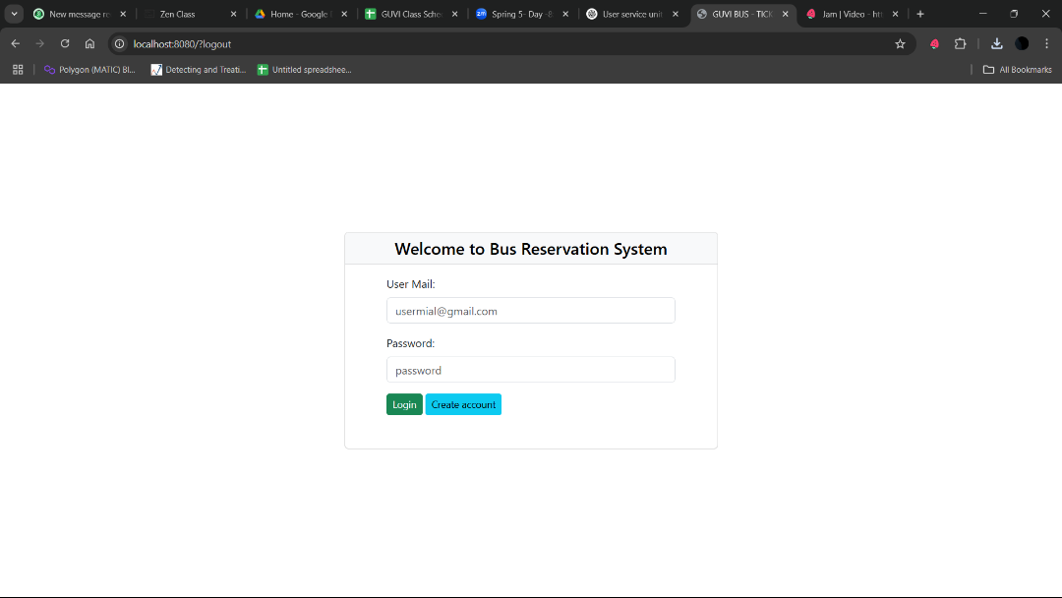

Screen 2: Registration Page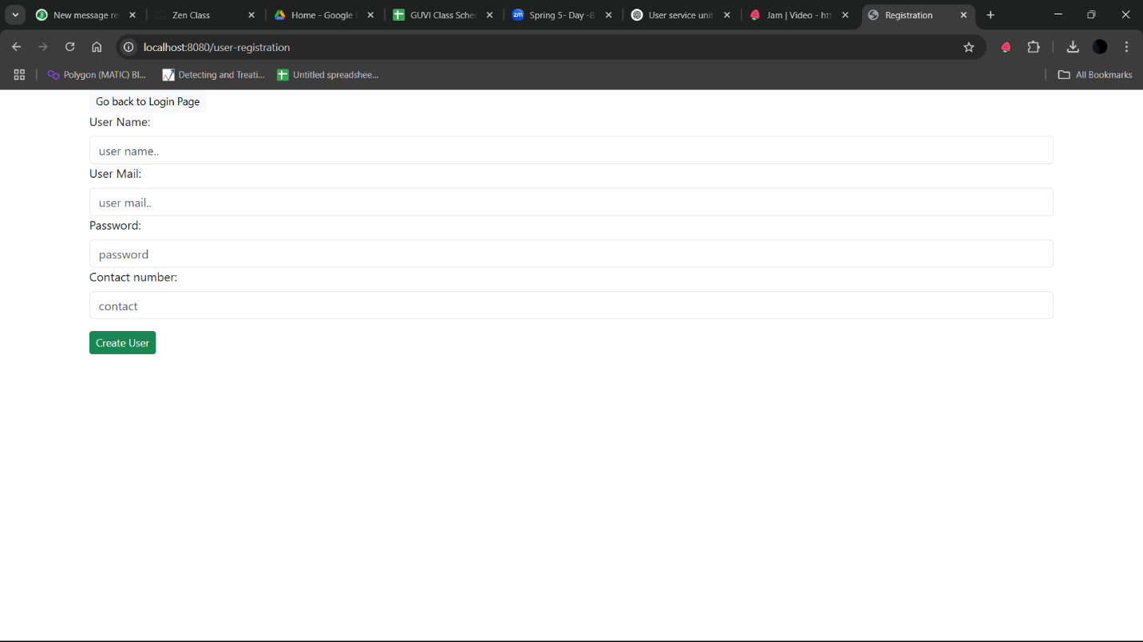

Screen 2: Registration Page with validation

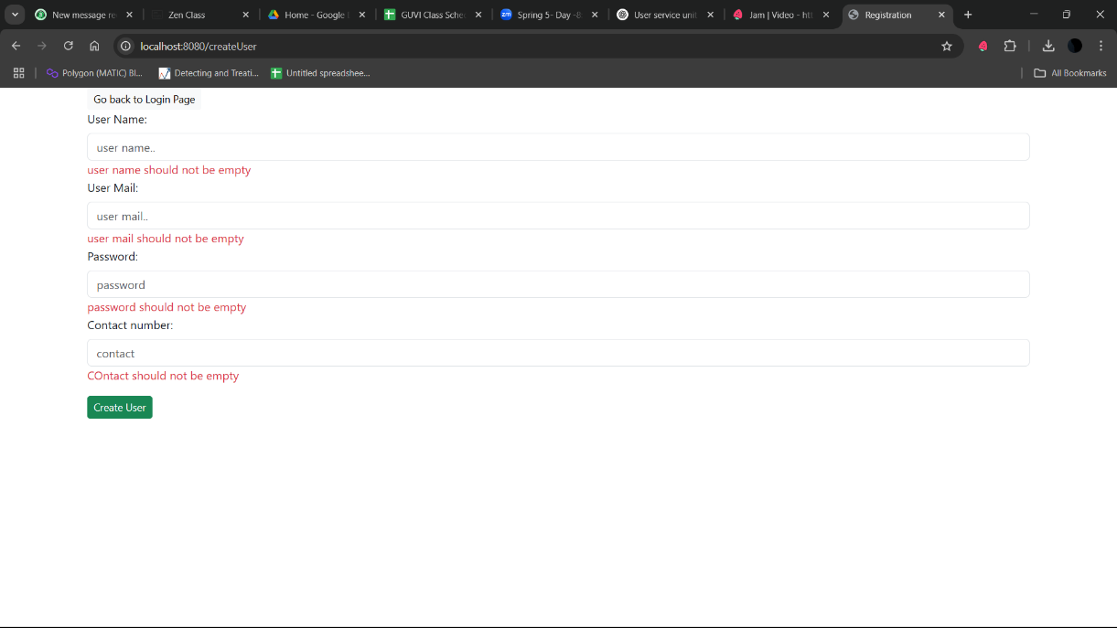

Screen 3 : Find Bus Screen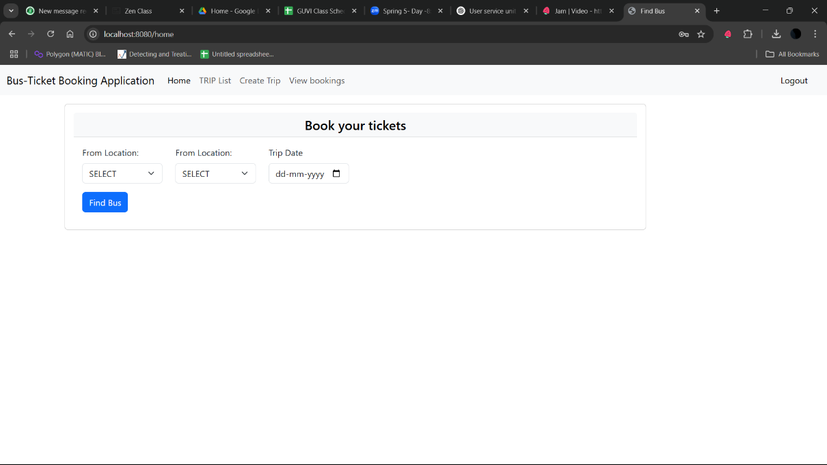

Screen 4: Bus List Screen

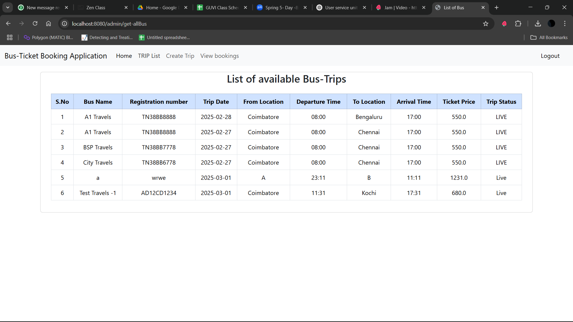

Screen 5: Bus-Trip creation screen

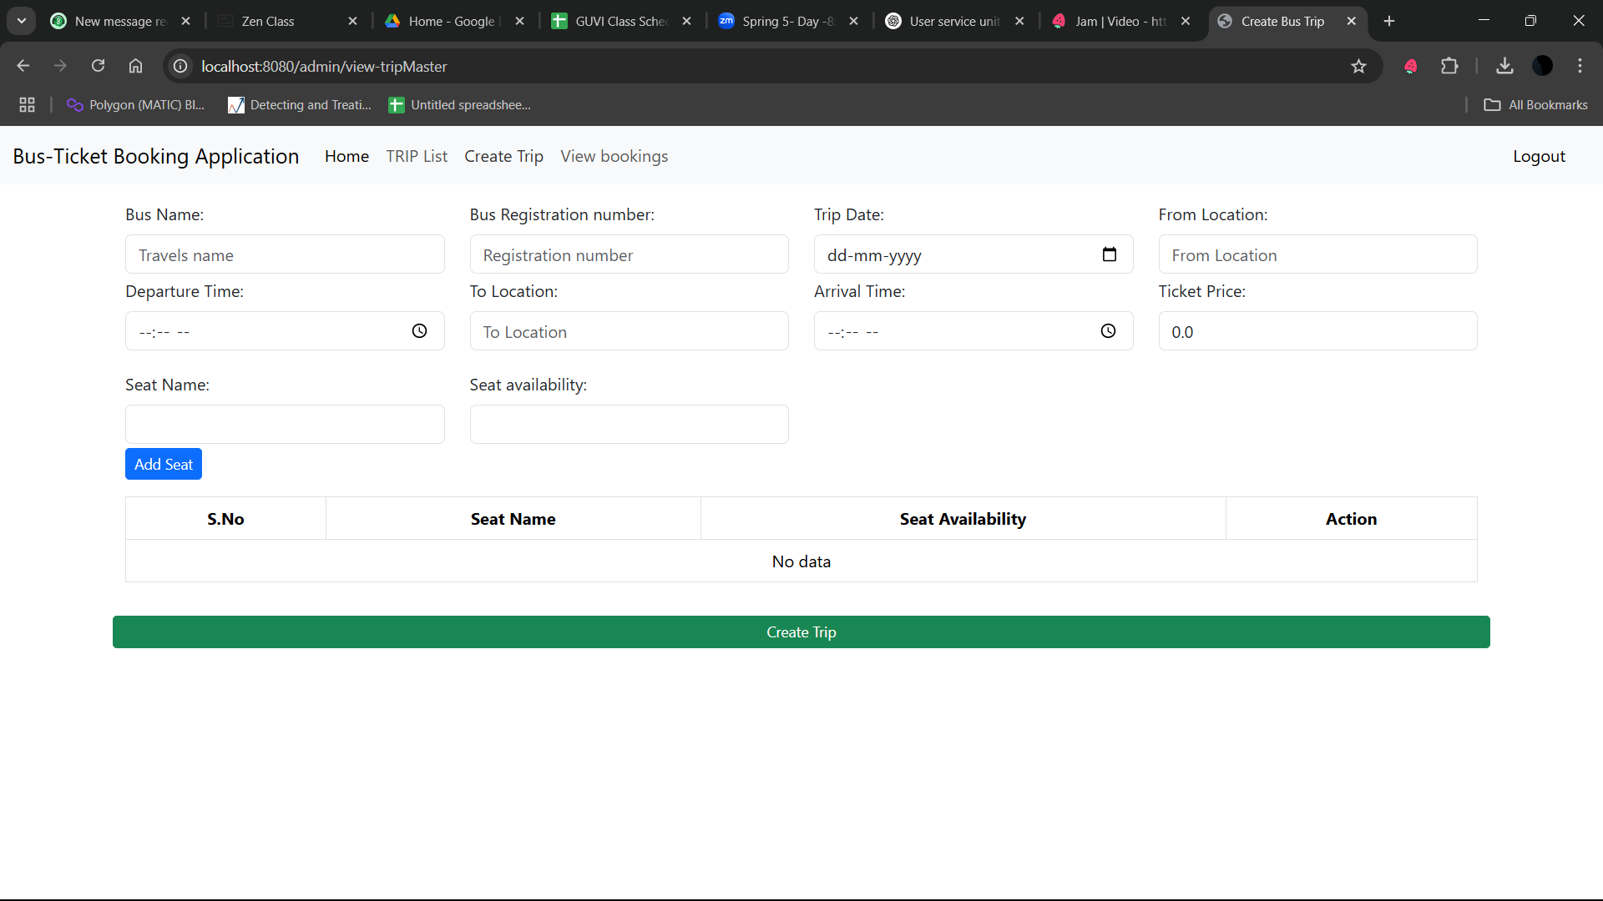

Screen 5: Bus-Trip creation screen with validation

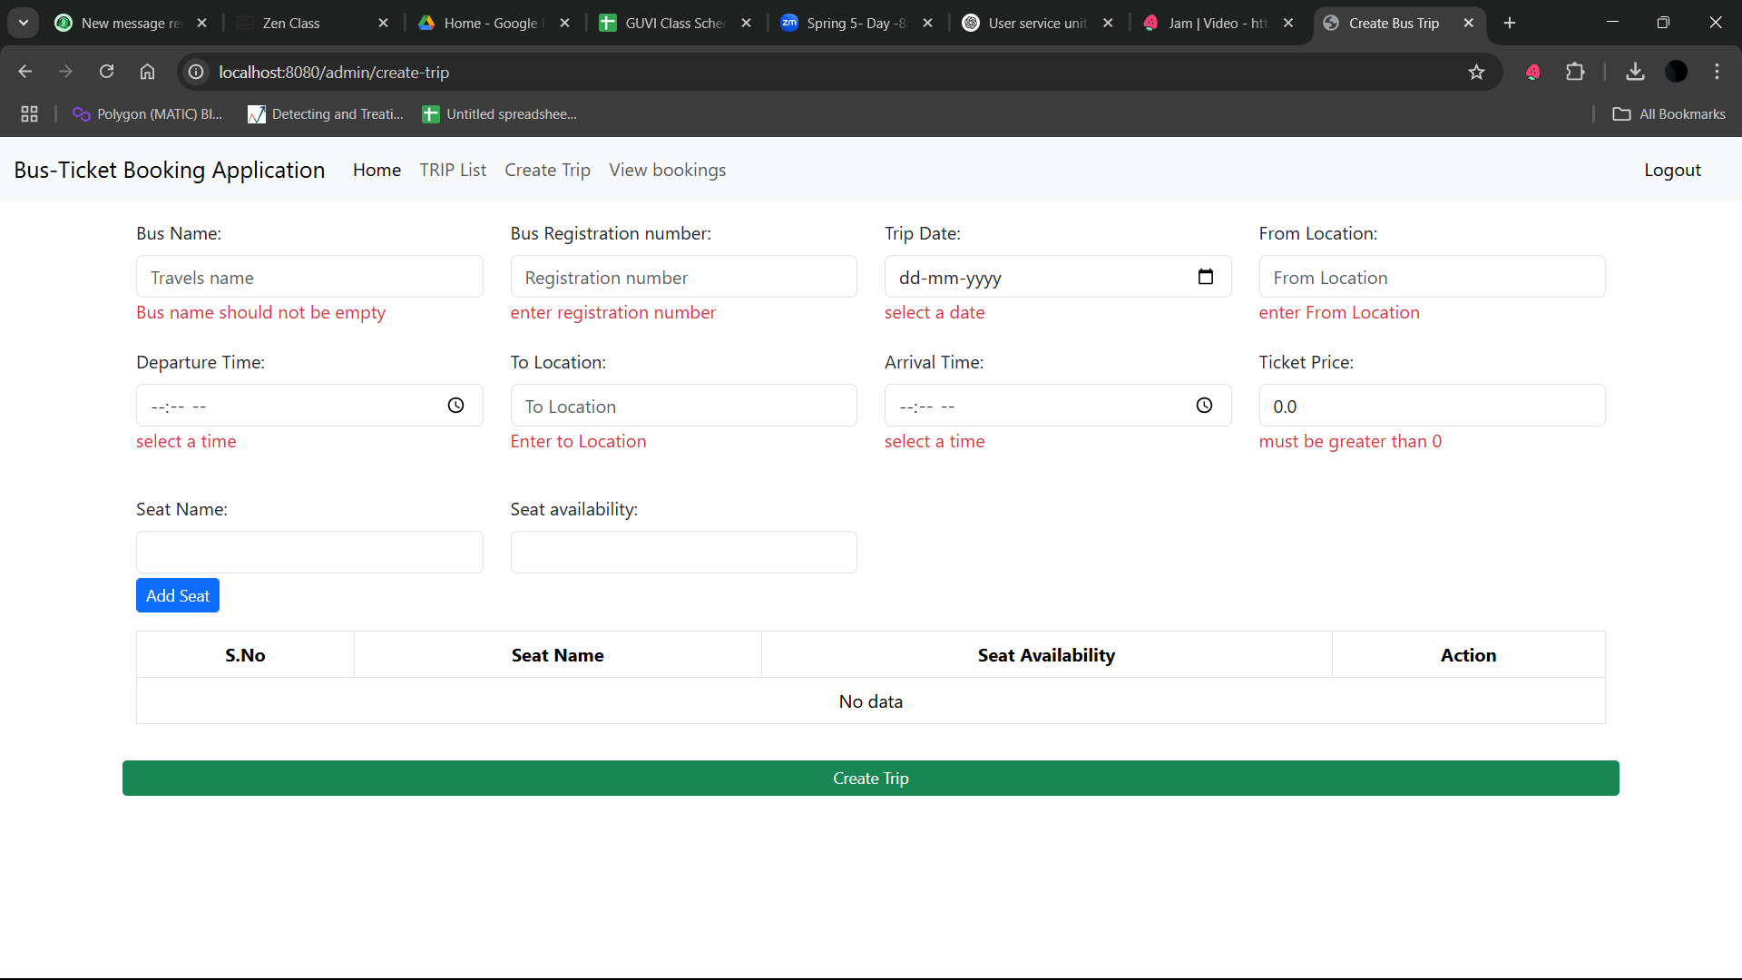

Screen 6: Booking History (Ticket History)

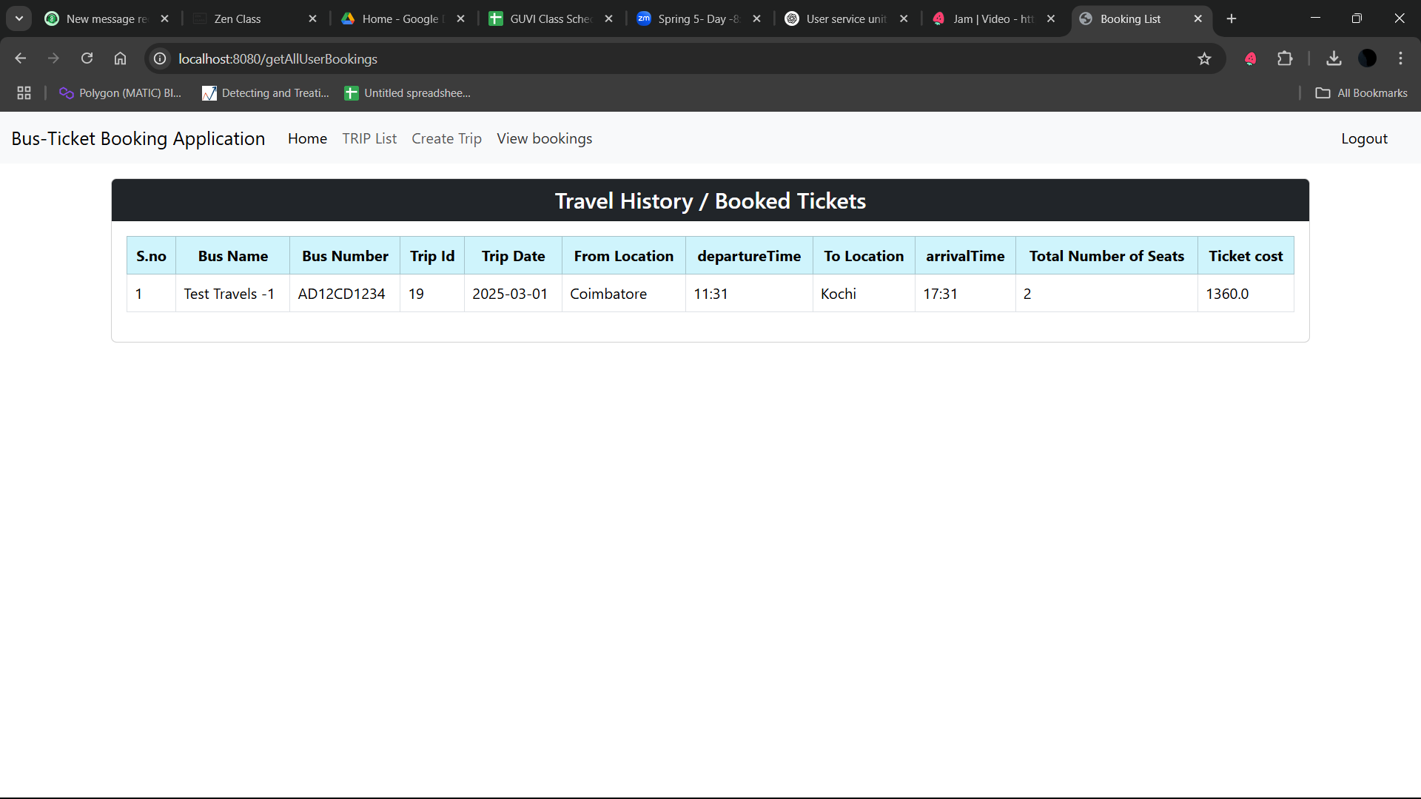

Screen 7: List of Bus base on selected from and to locations

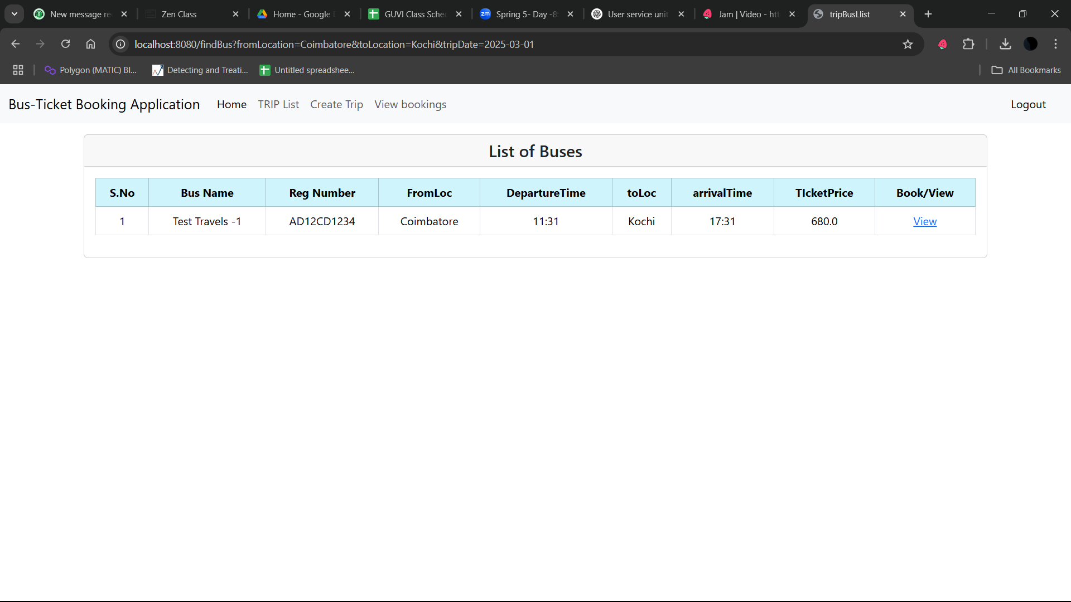

Screen 8: Seat selection Passenger Details to book ticket

